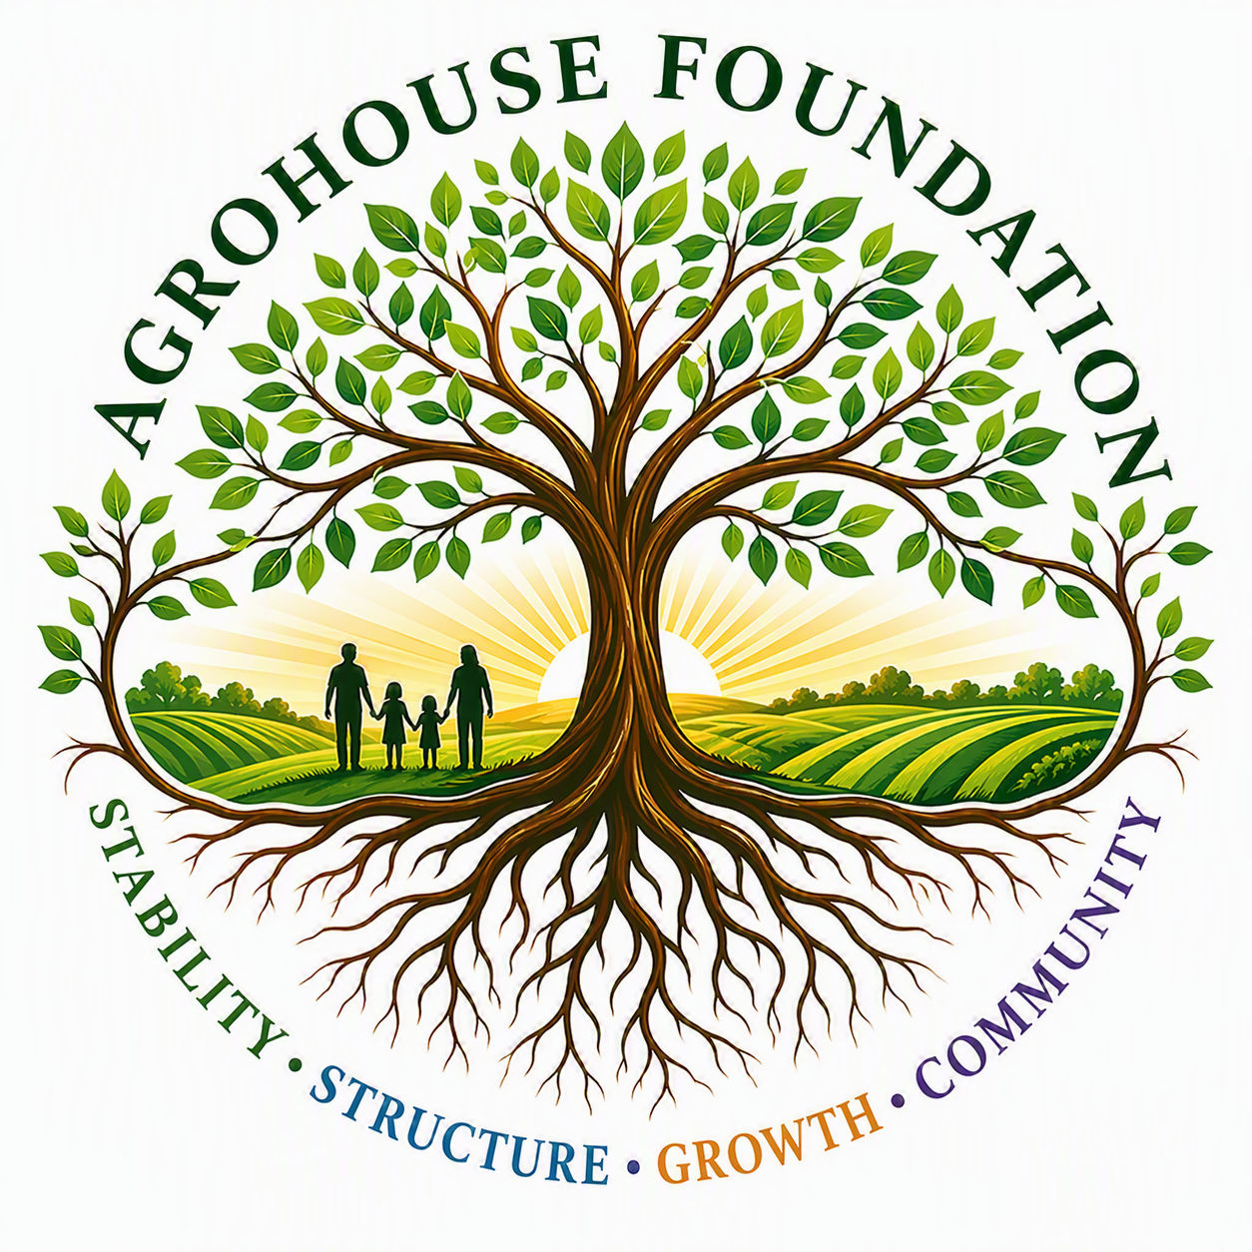
MEMORANDUM OF UNDERSTANDING
Community Outreach Partnership
BETWEEN
AGHF Inc.
d/b/a AgroHouse Foundation
AND
____________________________________________
(Church Legal Name)
d/b/a "The Bridge"
Effective Date: ______________________________

This Memorandum of Understanding (“MOU”) is entered into as of the Effective Date shown above, by and between AGHF Inc., a Florida nonprofit corporation d/b/a AgroHouse Foundation (“AgroHouse Foundation”), and ____________________________________________, a [fill in entity type, e.g., Florida religious nonprofit corporation] d/b/a “The Bridge” (“The Bridge”), operating in Zephyrhills, Florida. AgroHouse Foundation and The Bridge may be referred to individually as a “Party” and collectively as the “Parties.”
1. Background
• The Bridge operates a community outreach ministry in Zephyrhills, Florida, currently serving an estimated 125 individuals per week, with participation continuing to grow.
• AgroHouse Foundation is a Florida nonprofit corporation (AGHF Inc.) organized to strengthen communities through outreach stabilization, food security, sustainable agriculture, workforce development, and future vocational housing initiatives.
• AgroHouse Foundation's Community Outreach Stabilization Program (“Program 1”) is designed to strengthen existing community outreach efforts through the procurement and distribution of meals, hygiene resources, hydration resources, logistical support, storage solutions, and related infrastructure.
• The Parties wish to formalize a cooperative working relationship in which AgroHouse Foundation provides stabilization support to the outreach operated by The Bridge, without altering The Bridge's ownership, direction, or control of its own ministry and programming.
2. Purpose
The purpose of this MOU is to establish a shared understanding of roles, responsibilities, and expectations between AgroHouse Foundation and The Bridge in support of The Bridge's community outreach, and to document the cooperative, non-exclusive partnership between the Parties.
3. Roles & Responsibilities
Each Party agrees to the following respective responsibilities in support of the outreach:
The Bridge | AgroHouse Foundation
• Operate and direct all outreach ministry activities | • Procure meal, hygiene, and hydration resources
• Coordinate and supervise volunteers | • Provide coffee and hydration station support
• Maintain the outreach schedule and group activities | • Assemble and provide hygiene / blessing bags
• Provide approved facility access for outreach operations | • Support storage and logistics infrastructure
• Lead community engagement and participant relationships | • Assist with inventory management and sustainability planning

4. Independence of the Parties
AgroHouse Foundation supports and strengthens the outreach operated by The Bridge but does not control, manage, supervise, or direct The Bridge's programming, volunteers, donations, or ministry activities. Nothing in this MOU creates an employer-employee relationship, agency relationship, partnership, or joint venture between the Parties. Each Party remains solely responsible for its own staff, volunteers, operations, and legal and financial obligations.
5. Outreach Details
Outreach Name:
Outreach Days:
Outreach Hours:
Group Activity Hours:
Estimated Weekly Reach:
Location / Facility:
Note: The outreach currently operates Monday, Wednesday, and Friday, approximately 2:00 PM – 5:00 PM, with group activities from 5:00 PM – 7:00 PM, and is currently reaching an estimated 125 individuals per week with numbers continuing to grow. Figures above should be confirmed and updated as the outreach evolves.

6. Points of Contact
AgroHouse Foundation Contact:
Title:
Email / Phone:

The Bridge Contact:
Title:
Email / Phone:
7. Financial Provisions
This MOU does not obligate either Party to provide funding to the other. AgroHouse Foundation's support is contingent upon available grant funding, donations, sponsorships, and community resources, and may fluctuate accordingly. Each Party is responsible for its own costs, staff, and volunteers unless otherwise agreed in a separate signed writing. AgroHouse Foundation operates on a debt-free, grant- and donation-funded basis and assumes no debt or financial liability on behalf of The Bridge.
8. Non-Exclusivity
This MOU is non-exclusive. Either Party may enter into similar cooperative arrangements with other organizations, ministries, or partners without breaching this MOU.
9. Term & Termination
This MOU shall become effective as of the Effective Date and shall continue until terminated by either Party. Either Party may terminate this MOU at any time, with or without cause, by providing thirty (30) days' written notice to the other Party. This MOU may be reviewed and updated periodically by mutual agreement as the outreach and the Parties' partnership evolve.
10. Amendments
This MOU may be amended or modified only by a written document signed by authorized representatives of both Parties.
11. Nature of Agreement
This MOU is intended to document the mutual understanding, working relationship, and good-faith intentions of the Parties. It is not intended to be a legally binding contract enforceable in a court of law, except with respect to any provisions the Parties expressly agree in writing are binding. Each Party will act in good faith to fulfill the intentions expressed in this MOU.
12. Signatures
By signing below, each Party acknowledges that it has read, understands, and agrees to this Memorandum of Understanding.
For AGHF Inc. d/b/a AgroHouse Foundation:
Signature:
Printed Name:
Title:
Date:
For ____________________________________________ d/b/a "The Bridge":
Signature:
Printed Name:
Title:
Date:

